**Project Structure**

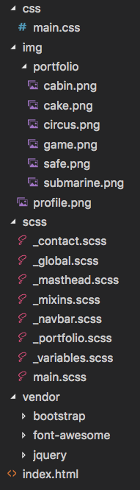

**Colors**

|  |  |
| --- | --- |
| Greenish | #18bc9c |
| Blueish | #2c3e50 |
| Contact form input text | #495057 |

**Navbar when expanded on small resolutions:**

